1) Install MadCollection (Mad except 5 and other components)  
see madCollection folder

2) Virtual tree view  
see install.txt in VirtualTreeView7 Folder

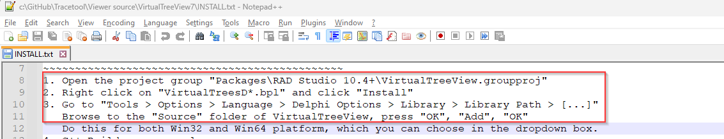

3) Synedit : install from get it manager

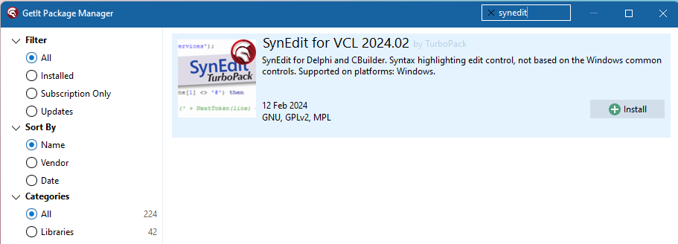

Add missing $(BDSCatalogRepository)\SynEdit-11\source\Highlighters for 32 and 64 environment

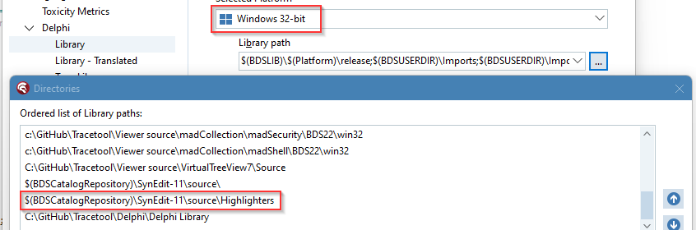

4) TPrintPreview, TThumbnailPreview  
Open Preview\PreviewPackage.dproj  
right click PreviewPackage.bpl, install

5) FastMM 5

6) Path

